Exercise 8
Unit Testing using JUnit

Aim
To develop a Java class and verify its behavior using JUnit 5 unit tests.

Software Required
- JDK 17+
- IntelliJ IDEA
- JUnit 5

Procedure
- Create a Java project in IntelliJ IDEA.
- Add JUnit 5 as the test dependency if it is not already available.
- Create Calculator.java.
- Create CalculatorTest.java in the test source directory.
- Add the @Test methods.
- Run the test class.
- Observe the green/passed test results.
- Change one expected value intentionally and run again to observe a failed test.
Calculator.java
import java.util.Scanner;
public class Calculator {
public int add(int a, int b) {
return a + b;
}
public int subtract(int a, int b) {
return a - b;
}
public int multiply(int a, int b) {
return a * b;
}
public double divide(int a, int b) {
return (double) a / b;
}
public int square(int a) {
return a * a;
}
public boolean isEven(int a) {
return a % 2 == 0;
}
public static void main(String[] args) {
Scanner sc = new Scanner(System.in);
Calculator calc = new Calculator();
System.out.print("Enter first number: ");
int a = sc.nextInt();
System.out.print("Enter second number: ");
int b = sc.nextInt();
System.out.println("Addition = " + calc.add(a, b));
System.out.println("Subtraction = " + calc.subtract(a, b));
System.out.println("Multiplication = " + calc.multiply(a, b));
if (b != 0) {
System.out.println("Division = " + calc.divide(a, b));
} else {
System.out.println("Division = Cannot divide by zero");
}
System.out.println("Square of first number = " + calc.square(a));
System.out.println("Is first number even? = " + calc.isEven(a));
sc.close();
}
}
Output:
Enter first number: 25
Enter second number: 20
Addition = 45
Subtraction = 5
Multiplication = 500
Division = 1.25
Square of first number = 625
Is first number even? = false

Process finished with exit code 0

CalculatorTest.java
import org.junit.jupiter.api.Test;
import static org.junit.jupiter.api.Assertions.*;
class CalculatorTest1 {
@Test
void add() {
}
@Test
void subtract() {
}
@Test
void multiply() {
}
@Test
void divide() {
}
@Test
void square() {
}
@Test
void isEven() {
}
}
Output:
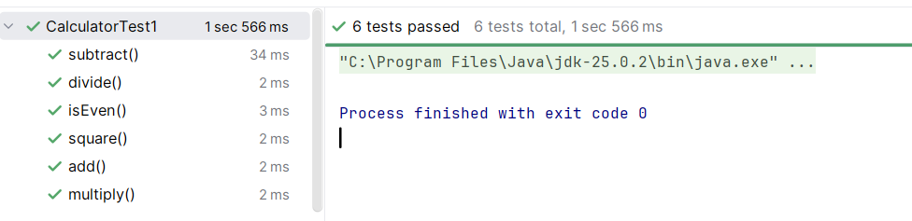

Result
Thus the experiment was successfully performed and the expected result was obtained.

